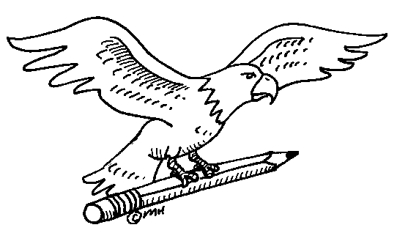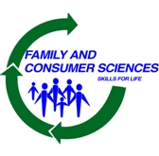

**Welcome to 7th grade Home & Career Skills**

**Mrs. Tina Cislo**

[**tcislo@lakeshorecsd.org**](mailto:tcislo@lakeshorecsd.org)

**716-926-2477**

Dear

Dear students & families,

I would like to welcome your child to Home & Career Skills Class. 7th grade Home & Career Skills classes will meet for a total of 10 weeks.

Home and Career Skills is a course designed to help middle school students live in a society of constant change and to improve their quality of life by preparing them to meet their present and future responsibilities as family and community members, consumers, home managers, and wage earners.

During these 10 weeks students will learn basic sewing skills including the use of a sewing machine through the construction of a small gym bag. Students will be working on this project in class. In the event a student falls behind they **will be required to stay after school** to catch up. Students will not be allowed to participate in food labs until this project is complete.

Students will also have an opportunity to learn some basic cooking skills. Students will be able to read recipes, measure ingredients, practice safe cooking & prepare food products. Students will study quick breads, cookies and weight management in the foods unit.

Students are required to come to class prepared and on time**. Students are required to bring a folder with pockets, 10 pages of lined paper & a pen/pencil to class every day.** All other materials will be provided for your child to successfully complete this course.

Grading will be based on class activities & projects, homework & a 10 week unit test. Points will be deducted for late work, starting with a 10 point penalty.

I am looking forward to having your child in class and helping them become independent individuals.

If you have any questions or concerns please feel to contact me at any time.